**Topological Business Rules**

Feature classes (unique identifier)

* Atomic Polygon (ATOMICID)
* Node (NODEID)
* Linear features (SEGMENTID)
  + Centerline
  + NSF (Non-Street Feature)
  + Subway
  + Rail
  + Shoreline

Topological rules

* Endpoints of all linear features are coincident to a Node feature
* Not all Node features are coincident to a linear feature endpoint
* The edge of an Atomic Polygon feature is coincident to at least 1 linear feature.
* Not all linear features are coincident to the edge of an Atomic Polygon, certain attributes in the linear features require the linear feature to be land-hooked (internal to an atomic polygon)
* Linear features cannot cross another linear feature but may be coincident

**Polygon Hierarchy**

Atomic Polygons are the building blocks of all the district polygons that we maintain.

A geometry update to an edge of a polygon that is coincident to the edge of a polygon of another polygon feature class and is directly related to it, will trigger the regeneration of the polygon in the lower tiered feature class. An editor can only change the geometry of an Atomic Polygon, by reshaping a coincident linear feature or moving a node attached to the Atomic Polygon based to the topological rule above. Editors cannot directly reshape any other polygon feature classes within the maintenance system.

An attribute update to a polygon whose edge is coincident to the edge of a polygon of another feature class and is directly related to it, will trigger the regeneration of the polygon in the lower tiered feature class.

The hierarchy tree shows which polygons are directly based on which.

Flushing Avenue between Stanwix St and Evergreen Av is coincident to the edge of CT2020, CB2020, CT2010, CB2010, CT2000, CB2000, Health Area, Health Center District, Election, Community District, Fire Company, and Hurricane Evacuation Zone

Demo example #1A – reshaping centerline

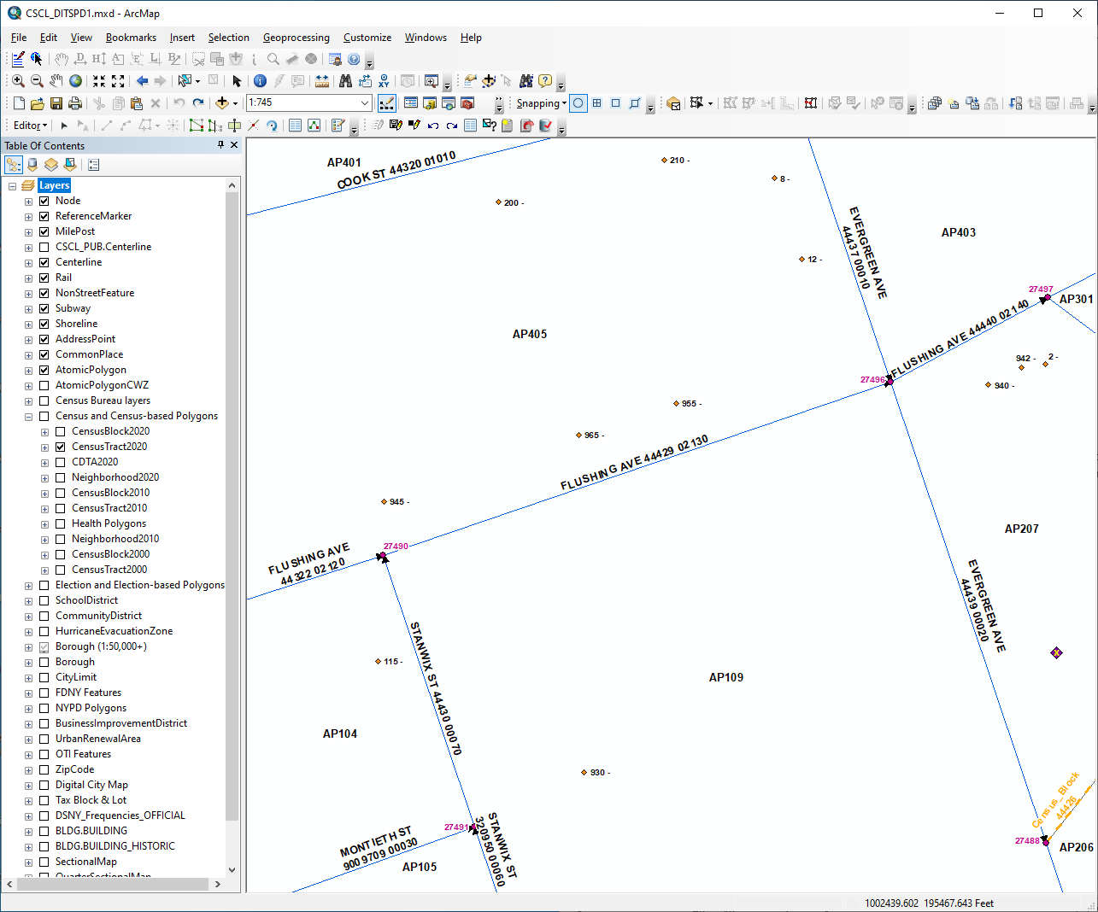

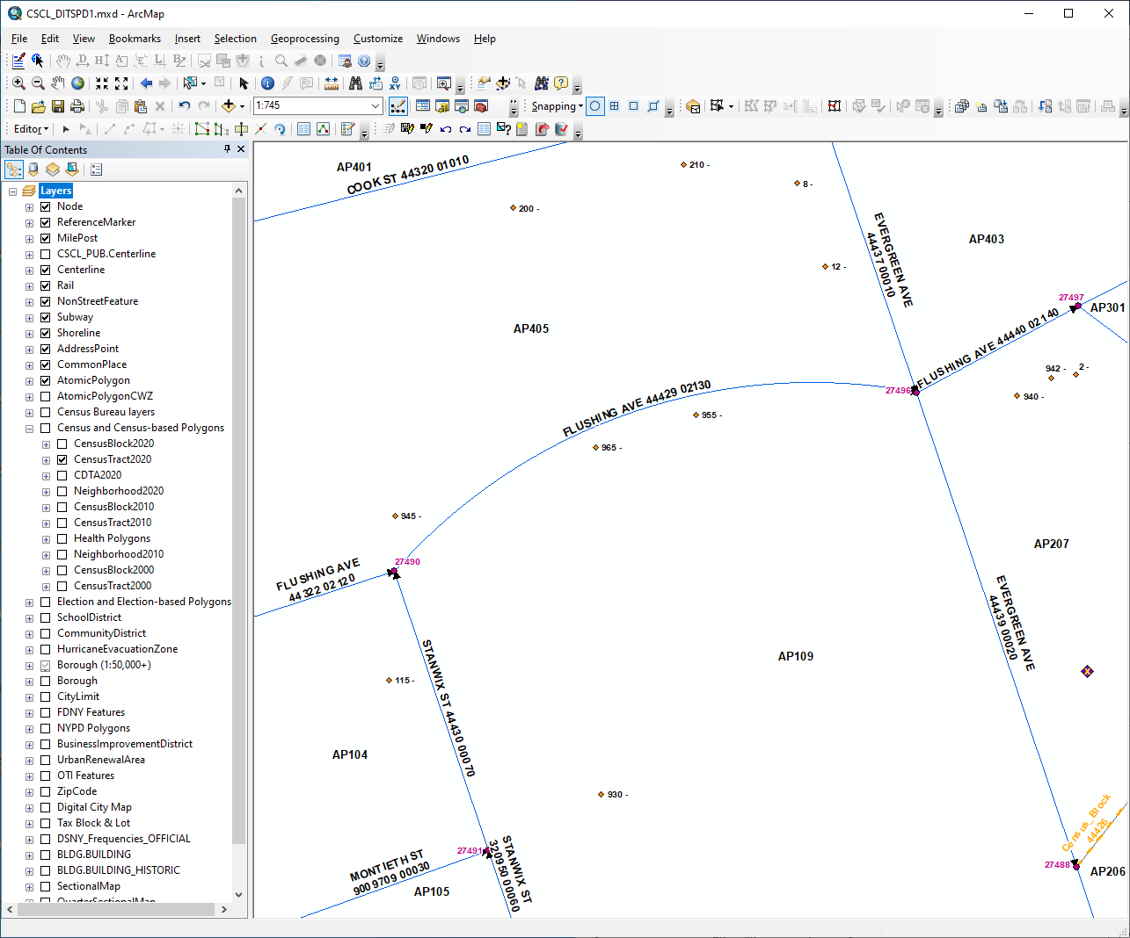

Demo example #1B – moving node



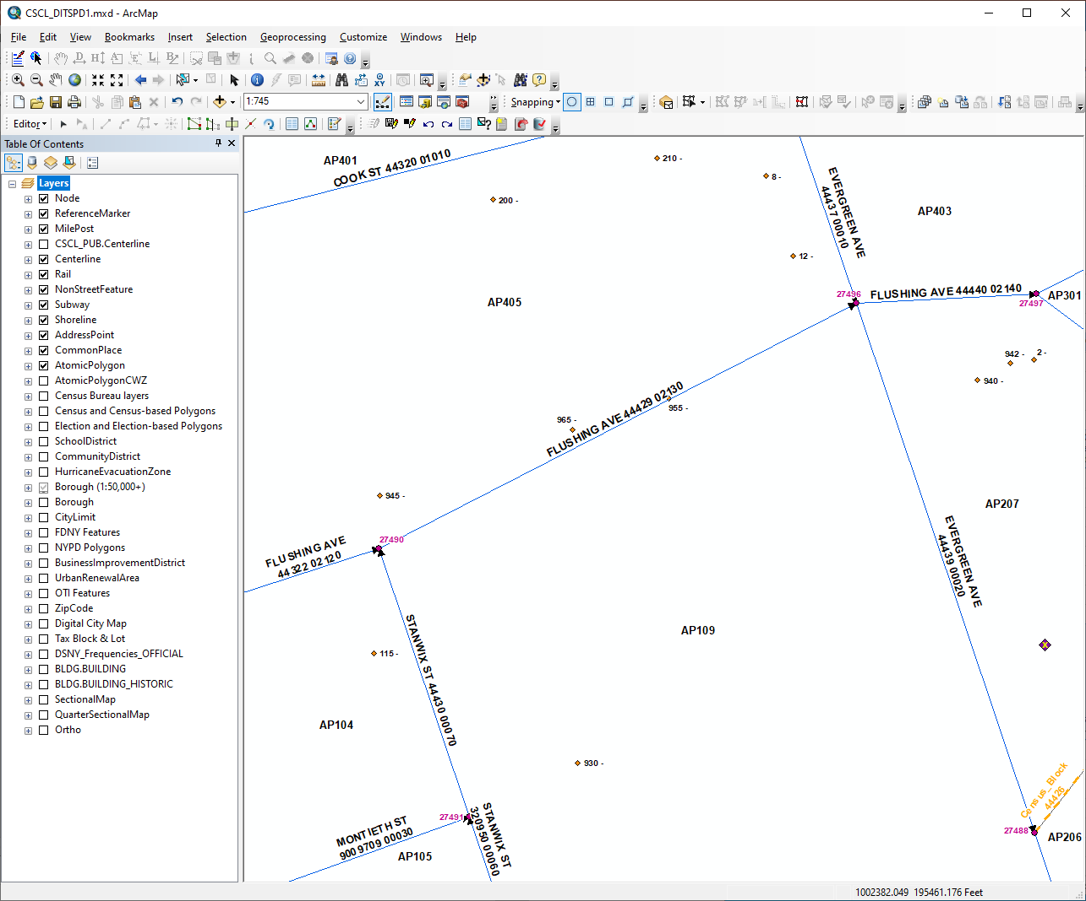

Demo example #1C– attribute update





Demo example #2– Split segments

Within an Atomic Polygon, add a centerline snapping to existing centerlines, splitting the block in half lengthwise. This action should split the underlying Atomic Polygon along the placement of the linear feature.

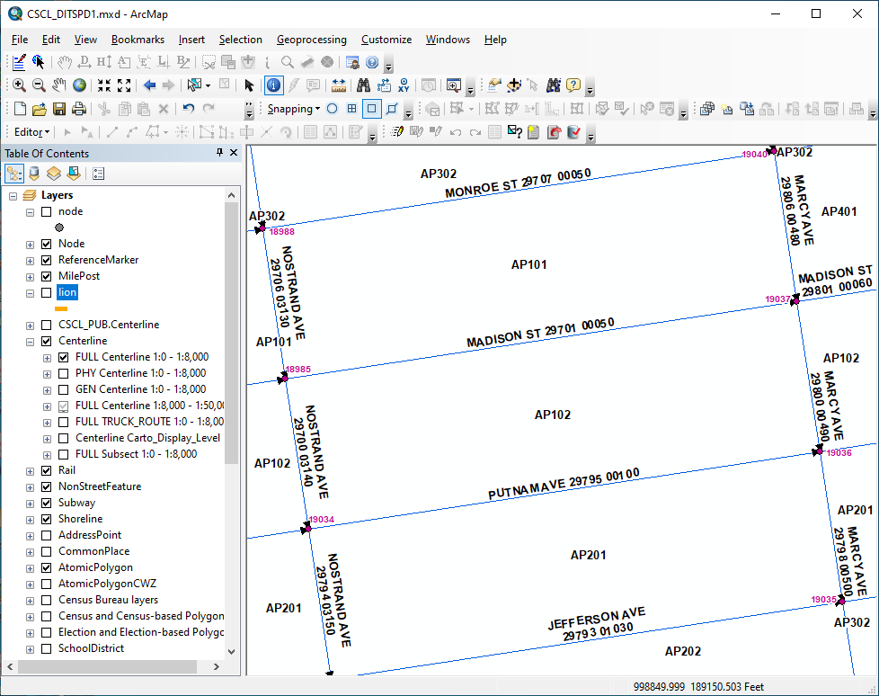

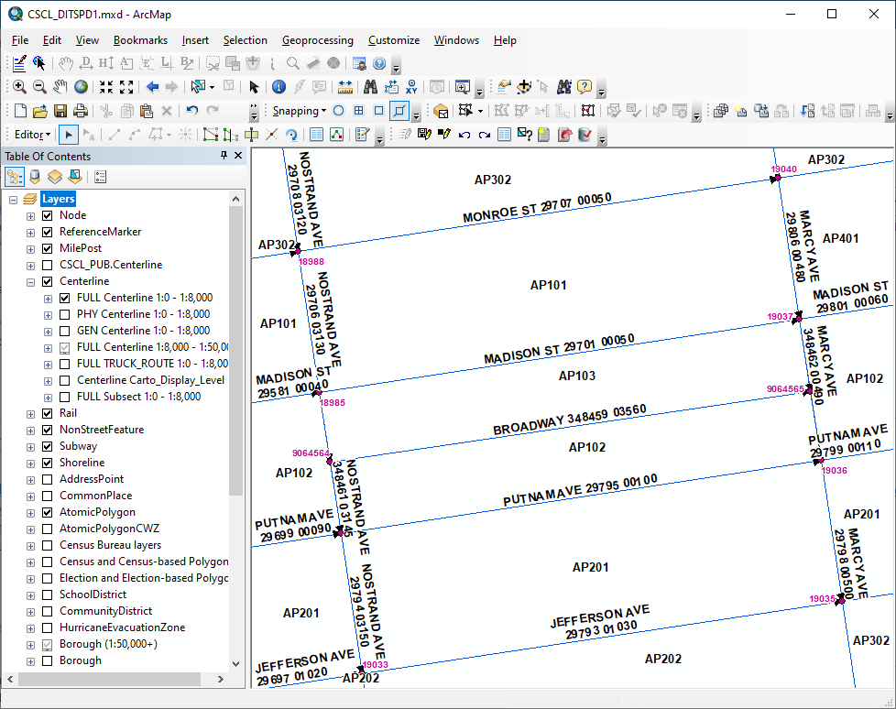

Features added automatically

* CSCL.Node

Records written to related tables automatically

* + CSCL.SEGMENT_LGC
  + CSCL.STREETSHAVEINTERSECTIONS
  + CSCL.CENTERLINEHISTORY

Automated ID assignments on Centerline fields

* + SEGMENTID
  + PHYSICALID
  + GENERICID
  + Sequence number

Automated ID assignments on Atomic Polygon field

* ATOMICID

Automated ID assignments on Node field

* NODEID

Mandatory Centerline fields

* Address number fields
* Roadway Type
* Segment Type
* Street Name

Resolution of centerline address distribution, AltSegementData address distribution, and reassignment of various features (addresspoints, commonplacepoints, referencemarkers, etc.) to child segments, due to splits by the editor

On the fly validations

* + Check for Address overlap
  + Field level validations for centerline fields
  + Segment orientation relative to existing centerlines of the same Face Code